**EXPERIMENT - 1**

**AIM:**

1. To create a web page to embed a map along with hot spot, frames &

Lines.

b) To create a web page using an embedded, external and inline CSS file.

**SOURCE CODE:**

1. Index.html:

<!DOCTYPE html>

<html lang="en">

<head>

<meta charset="UTF-8">

<meta name="viewport" content="width=device-width, initial-scale=1.0">

<title>Interactive Map with Hotspots</title>

</head>

<body>

<h2>Embedded Google Map</h2>

<iframe

src="https://www.google.com/maps/embed?pb=!1m18!1m12!1m3!1d243647.9491938636!2d78.33813456077842!3d17.41262736484332!2m3!1f0!2f0!3f0!3m2!1i1024!2i768!4f13.1!3m3!1m2!1s0x3bcb977c4186d6f1%3A0xc0e3e2977b4d80d2!2sHyderabad%2C%20Telangana!5e0!3m2!1sen!2sin!4v1612435805036!5m2!1sen!2sin"

width="900" height="450" style="border:0;" allowfullscreen="" loading="lazy">

</iframe>

<h2>Image Map with Hotspots</h2>

<img src="map_image.png" usemap="#map">

<map name="map">

<area shape="rect" coords="50,50,150,150" href="https://www.example.com" alt="Location 1">

<area shape="circle" coords="200,200,50" href="https://www.google.com" alt="Location 2">

</map>

<h2>Frames Example</h2>

<iframe src="https://www.w3schools.com" width="600" height="400"></iframe>

</body>

</html>

1. Index1.html:

<!DOCTYPE html>

<html lang="en">

<head>

<meta charset="UTF-8">

<meta name="viewport" content="width=device-width, initial-scale=1.0">

<title>CSS Example</title>

<!-- External CSS -->

<link rel="stylesheet" href="style.css">

<!-- Embedded CSS -->

<style>

h1 {

color: blue;

text-align: center;

}

</style>

</head>

<body>

<h1>CSS Styling Example</h1>

<p style="color: red; font-size: 18px;">This paragraph uses inline CSS.</p>

<div class="box">

This div is styled using external CSS.

</div>

</body>

</html>

Style.css:

body {

font-family: Arial, sans-serif;

background-color: #f4f4f4;

text-align: center;

}

.box {

width: 300px;

height: 100px;

background-color: lightblue;

margin: 20px auto;

padding: 20px;

border-radius: 10px;

}

**OUTPUT:**

a)

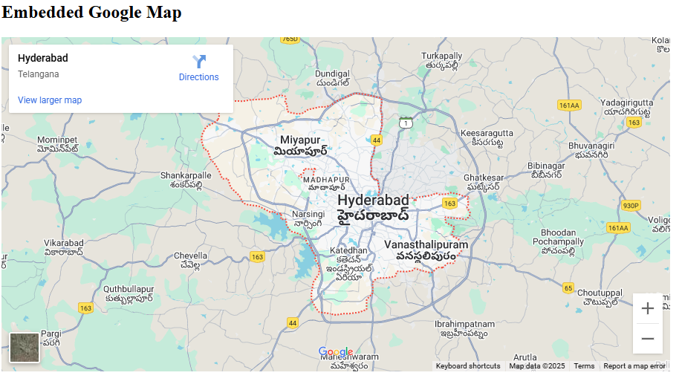

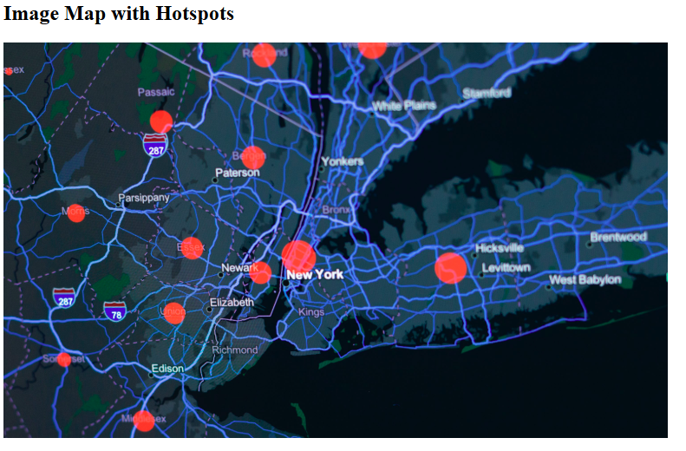

b)

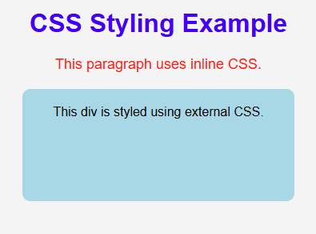

**RESULT:**

Thus the Web Page has been created.